VE day writing competition
Thank you for all the amazing insect fact files, I have had so much fun reading them and have learnt a lot about many different insects and arachnids.

The next competition is a little bit different… As many of you will be aware next Friday is the 75th anniversary of VE day. There was going to be lots of street parties, so I thought it might be fun for you to design your own street party poster.
- What could you share with a group of people?
- How many would you make?
- What decorations would you use?
- How would you make sure people knew it was to celebrate VE day?
- Where would you hold it?
- Would you have a dress code?
Try to make it as colourful and eye-catching as possible.

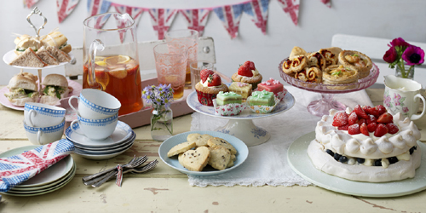
This competition will close on the 15th May
Please send your entries to: slt@petworthprimary.co.uk
Good luck and I look forward to seeing them.

