Micro:bit

This week we are going to focus on coding our fitness tracker.
Start by going to:
https://makecode.microbit.org/
Look back at your design from last week and use the code example below to code your Micro:bit.
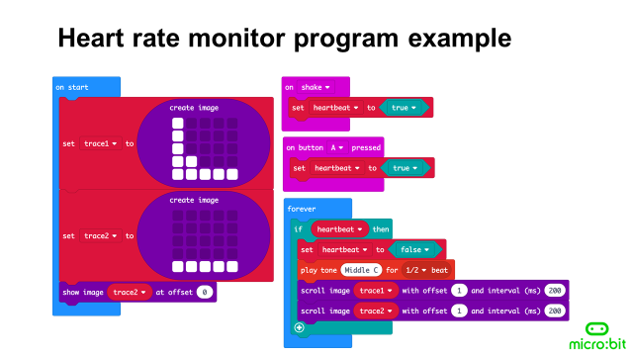
Extra challenge:
Can you make the LED display show different images for different exercises?
E.g. Can make a heartbeat for running, by pressing button A?
Can you make a person sitting down for resting, by pressing button B?

I look forward to hearing about your fitness trackers.
Good luck!

