Example of a planning sheet created at school:
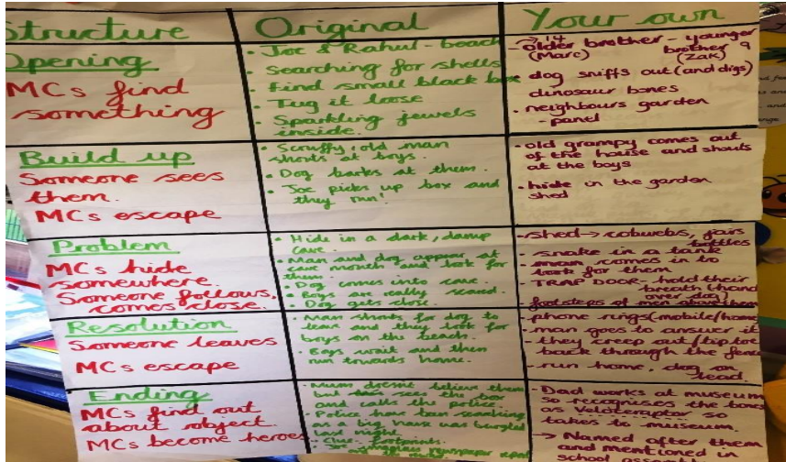

Opening
Build-up
Problem
Resolution
Ending

