Topic | Mon | Tues | Weds | Thurs | Fri
SPAG/ Reading | https://www.bbc.co.uk/bitesize/topics/zvwwxnb/articles/zshfdxs  Watch this clip on semi-colons and how they are used to separate two main clauses.  Complete the online quiz.  See if you can use a semi-colon in this week’s writing activities. | Last week, you practised converting between active and passive voice.  If you cannot remember how to do this, watch the video again.  https://www.bbc.co.uk/bitesize/topics/zwwp8mn/articles/zsx2b82  Convert these sentences from active to passive voice.  - Bethany sings lovely songs.  - Jack and Harry will run a race.  - Poppy had finished her work.  - Madison was writing a letter. | Complete ‘The Legend of the Elfwind’ reading comprehension. | How much can you remember about the active/passive voice?  Try these online quizzes:  https://www.englishclub.com/grammar/passive-voice-quiz.htm  https://www.grammarwiz.com/active-and-passive-voice-quiz.html | Using your current reading book, create a character profile.  Use the template provided.  Today is  ‘Number Day’
20min  activity | Spelling shed | Times-tables rock stars | Spelling shed | Times-tables rock stars | Spelling shed
Writing | Recap your knowledge of poetry types by watching this video:  https://www.bbc.co.uk/teach/class-clips-video/english-ks1-ks2-understanding-poetry/zfvkt39  Complete activities 1-3  https://www.bbc.co.uk/bitesize/articles/zdw83j6 | This week we will be writing a free-verse poem. You will find a selection of images in the resources provided to inspire your poetry.  Choose one of the images that captures your imagination. Generate some words and phrases linked to this image.  Include:  Adjectives  Verbs  Adverbs  Similes  Metaphors  Personification | Listen to this poem:  https://www.youtube.com/watch?v=wviha2H-8Mg  You might have noticed that the poet repeats a particular phrase: ‘Life doesn’t frighten me at all.’ When poems repeat a particular line or stanza, this is called a ‘refrain’.  Write a line or verse which sums up the subject of your poem.  This will be your refrain. Remember, this doesn’t have to rhyme. | Choose at least three different things you’ve noticed about the image and write a verse about each one.  Remember to use the vocabulary and phrases generated in Tuesday’s lesson.  Ensure that your refrain is repeated at various points in the poem. | Post your poem on the blog alongside the picture that inspired it.  Underneath, explain why you chose this subject and what you wanted the audience to feel when you wrote your poem.  As it is Number Day for the pupils of Petworth School, can you write a poem that uses numbers?  You could write one about how to calculate different fractions. Perhaps a poem entitled, “Imagine a world without numbers” or “The Day the Numbers Quit.”
Retrieval practice | Complete the STEM quiz on Socrative:  https://b.socrative.com/login/student/  Enter room: NEARY2456 |  | Complete the passive and active voice quiz on Quiz-Shed.  This activity has been assigned, you just need to login using your Ed Shed password. |  | Complete the Christianity retrieval activity on Quiz Shed.  This activity has been assigned, you just need to login using your Ed Shed password.
Topic | Computing:  Develop your typing speed by learning to ‘touch-type’ on this website:  https://www.bbc.co.uk/bitesize/topics/zf2f9j6/articles/z3c6tfr  Next, watch this clip and read the information:  https://www.bbc.co.uk/bitesize/topics/zs7s4wx/articles/z2nbgk7  Make a quiz of at least 5 questions (with answers) about how the internet works. | RE  We have been thinking about God’s Kingdom this term.  Today you have a parable to read. Parables are stories Jesus told help people learn about principles that were key to Christian belief.  What ‘messages’ do you think Jesus was trying to convey in this parable?  Complete the activity sheet with your own thoughts about forgiveness. | Science:  Watch this video clip about classification keys:  https://www.bbc.co.uk/bitesize/topics/zxjj6sg/articles/z9cbcwx  Choose one of two challenges:  Bronze – Fill in the missing questions in the classification key provided.  Silver/Gold – Create your own classification key using a selection of items of your choice. You can use anything from leaves to Pokémon!  . | Geography  Watch the videos on this link explaining 4 figure and 6 figure grid references.  https://www.ordnancesurvey.co.uk/blog/2015/11/map-reading-skills-how-to-read-a-grid-reference/  Complete the activity sheet in the resources section of the blog. | Art and Design  Sketching a number.  Choose your ability level:  Easiest:  How to Draw the Number 7 in 3D - YouTube  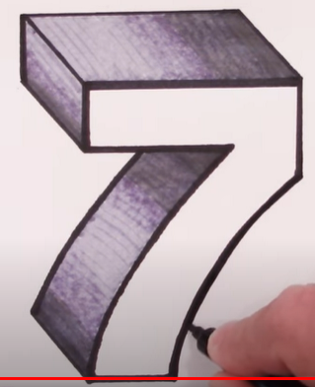  Medium:  How to Draw Floating 3D Number One Optical Illusion - #1 (mycrafts.com)  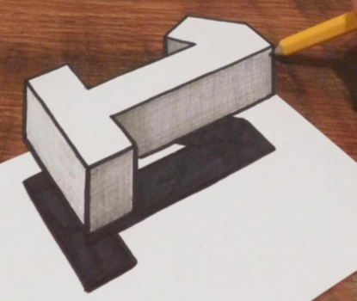  Harder:  Drawing with Only a Graphite Pencil - 3D Number Two - By Vamos - YouTube  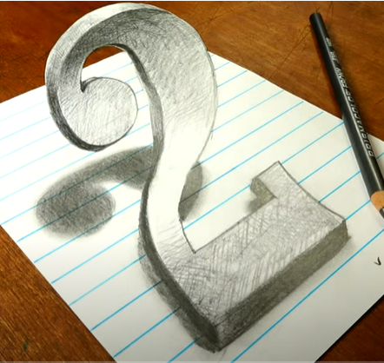
PE | Jo Wicks Workout  https://www.youtube.com/user/thebodycoach1  Live @ 9am |  | Jumpstart Jonny  (Choose your own workout)  https://www.jumpstartjonny.co.uk/free-stuff |  | Jo Wicks Workout  https://www.youtube.com/user/thebodycoach1  Live @ 9am

