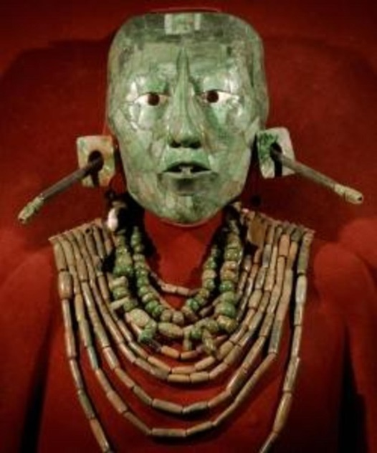[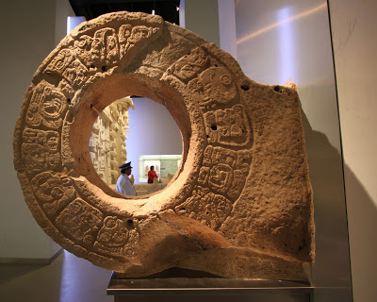](http://3.bp.blogspot.com/-4YokDMWWZos/UN4AM3obM8I/AAAAAAAABew/JhoDIxsPNPk/s1600/mayan+museum.jpg)

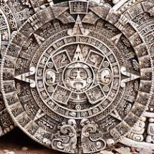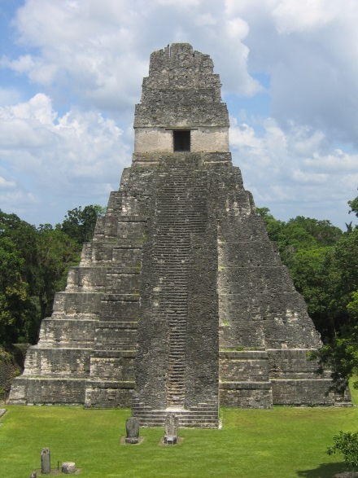

[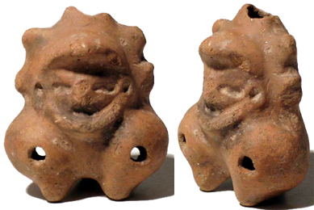](http://www.ancientresource.com/images/precolumbian/mayan/maya-ocarina-0611294a.jpg) 