L.O. To develop understanding of the concept of God's Kingdom

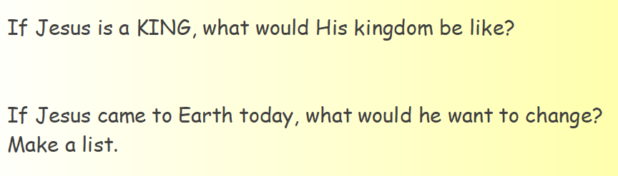

Have a look at these song lyrics. What do they tell us about Jesus as a King?
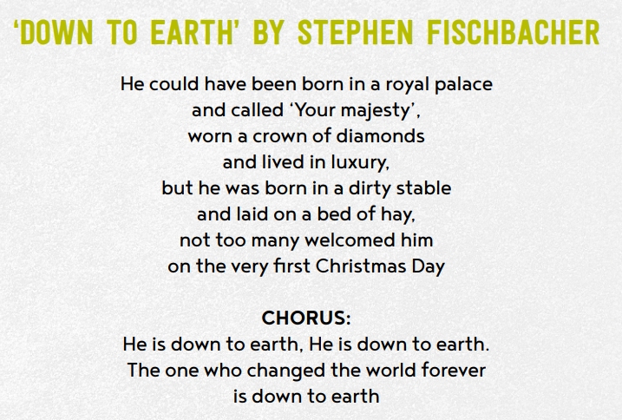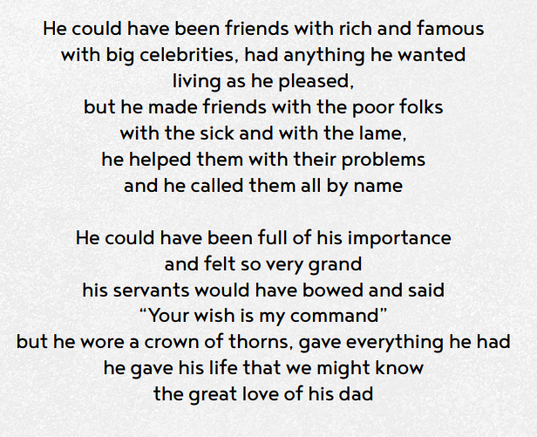
Have a go at writing your own song lyrics describing Jesus as a King.

You could use ideas from here to help you.

