A parable is a story Jesus told which enabled him to explain his teachings
in a way he knew that the people would remember.

They were a means in which he could teach principles that were central to Christian belief.

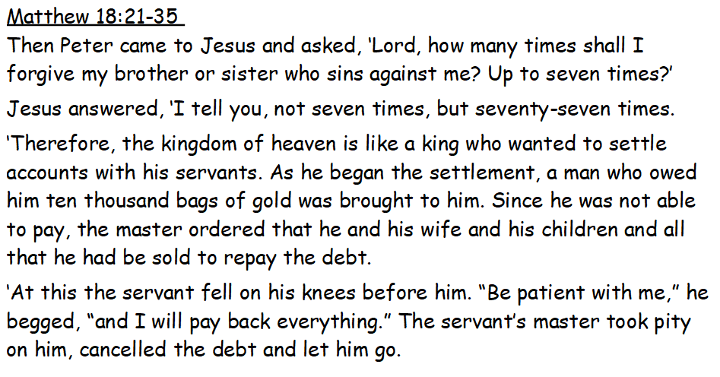

What messages would His followers have taken from this story?

This parable has two 'messages' within it.

1) God is forgiving – God is like the king who offers forgiveness to all.

2) If we are not like God in the way that we treat others and we do not learn to forgive, then we will be judged.

Christians believe that we need to show grace to all people just as God has shown grace to us. This teaching is echoed in the Lord’s Prayer,
‘Forgive us our sins
As we forgive those who sin against us.’
Should we always forgive others? When would it be difficult to forgive?
Look at the following scenarios.
Would you forgive? Should you forgive? Would it be easy or difficult?
Give a score out of 10 for how HARD it is to forgive each person.
