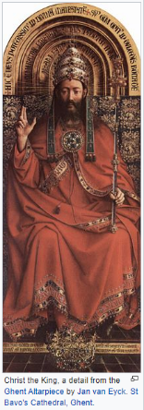
CHRIST THE KING
This is a title of Jesus in Christianity, referring to the idea of the
Kingdom of God where Christ is seated at the right hand of the
Father (GOD)

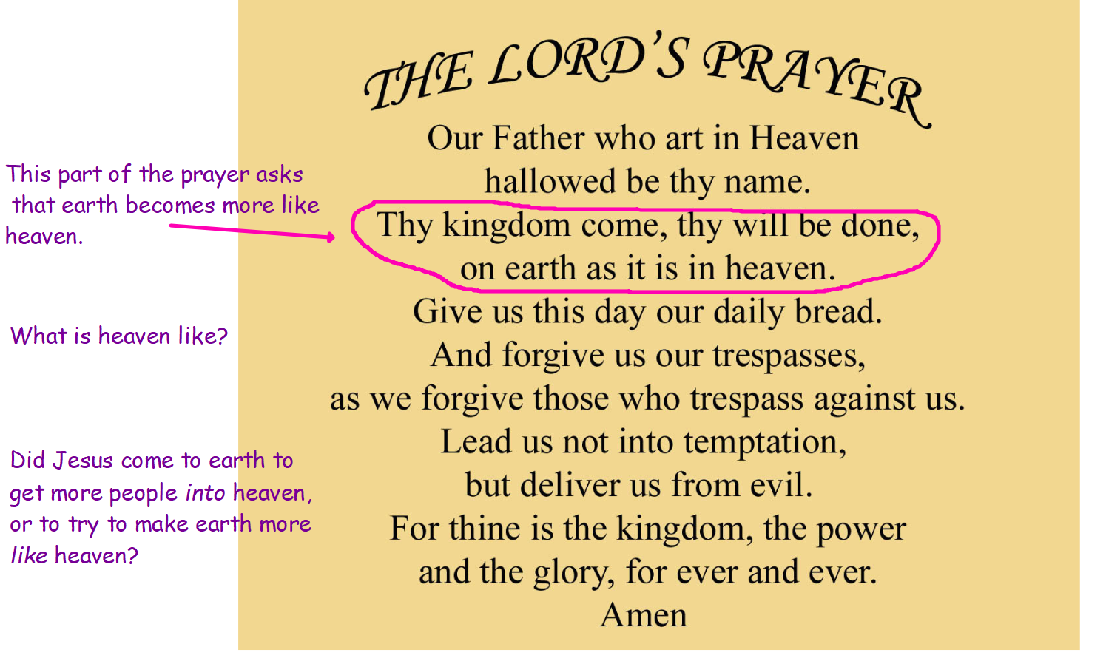
What things can be found on earth but not in heaven?

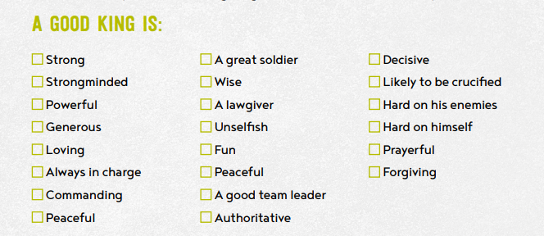
How many of these characteristics do you think describe Jesus?

