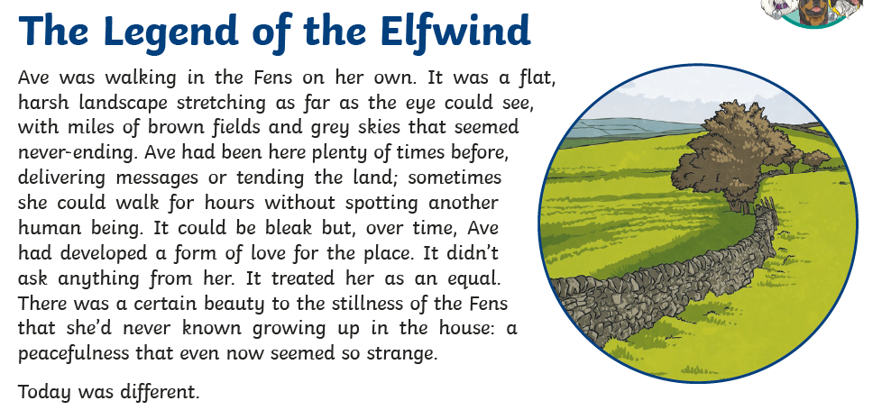
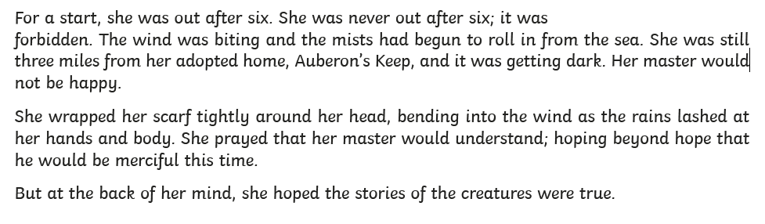
Q1: Find and copy two facts about the Fens from the first paragraph.
Q2: ‘…tending the land’
How else could the author have written this phrase?
Q3: Why do you think that it was forbidden to be out after 6 o’clock?

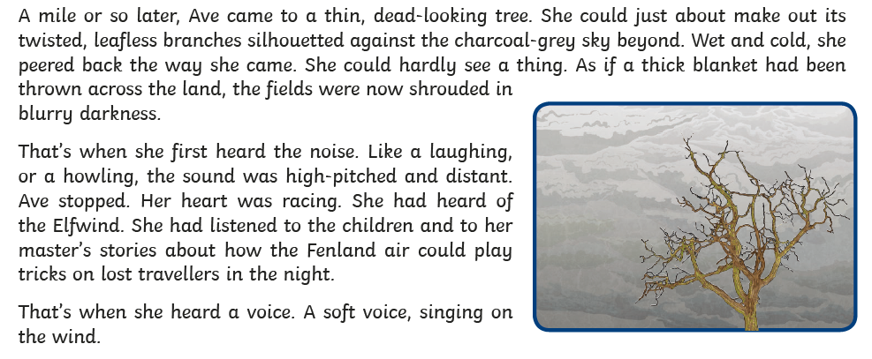

Q4: What was the name of the dyke that Ave walked along?
Q5: Find and copy three ways in which the author gives the impression that the setting is unpleasant.
Q6: ‘But Ave had no choice’
Why do you think that Ave felt this way?
Q7: How do you think Ave felt when she first heard the noise? Use evidence from the text to support your answer.

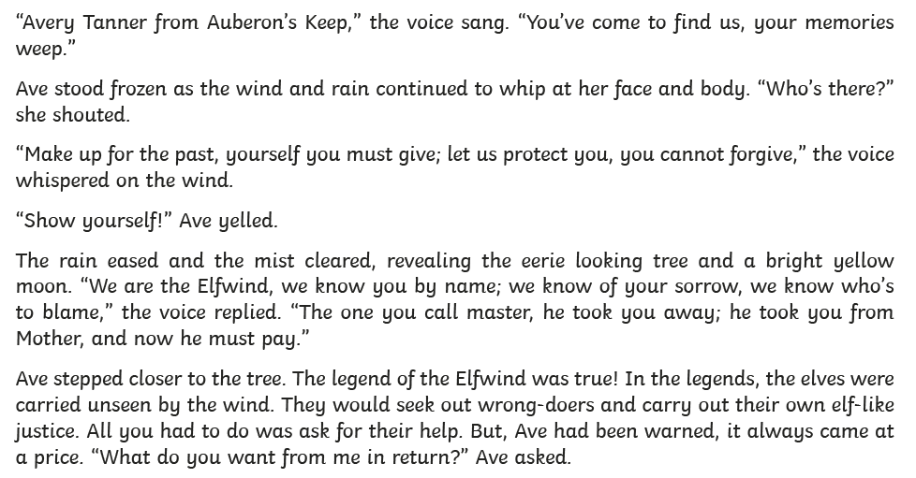
Q8: Why do you think that the author compares the mist to a thick blanket being thrown across the land?

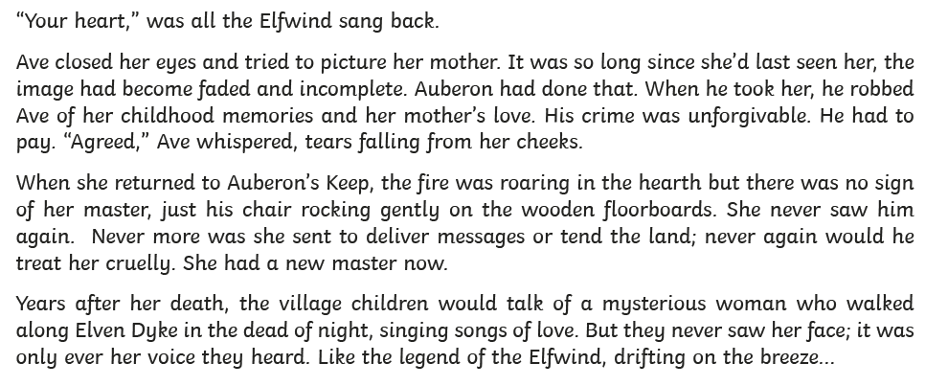
Q9: How does Ave’s life compare to her master’s?
Q10: Why did Ave stand frozen?
Q11: What do you think happened to Auberon?

