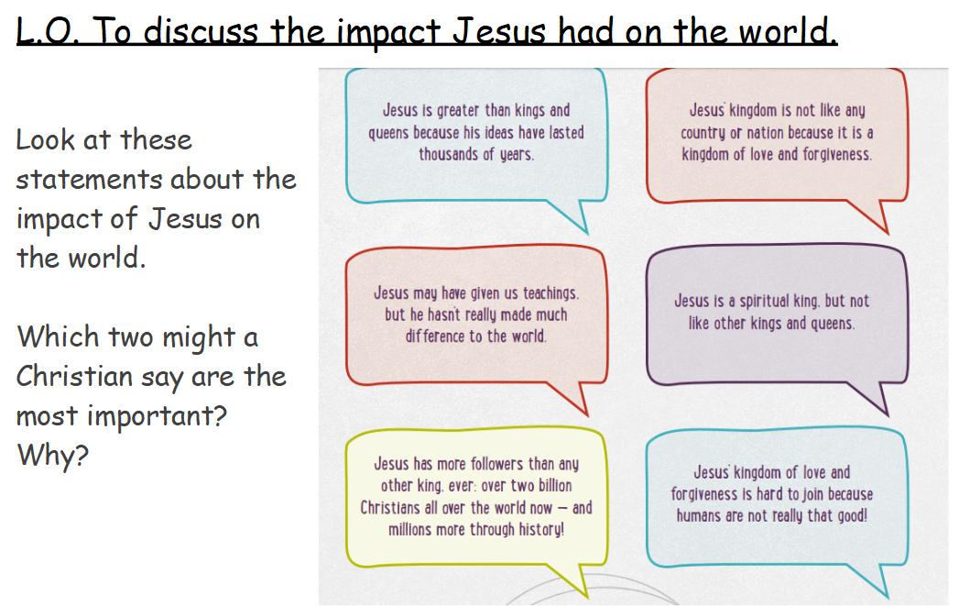
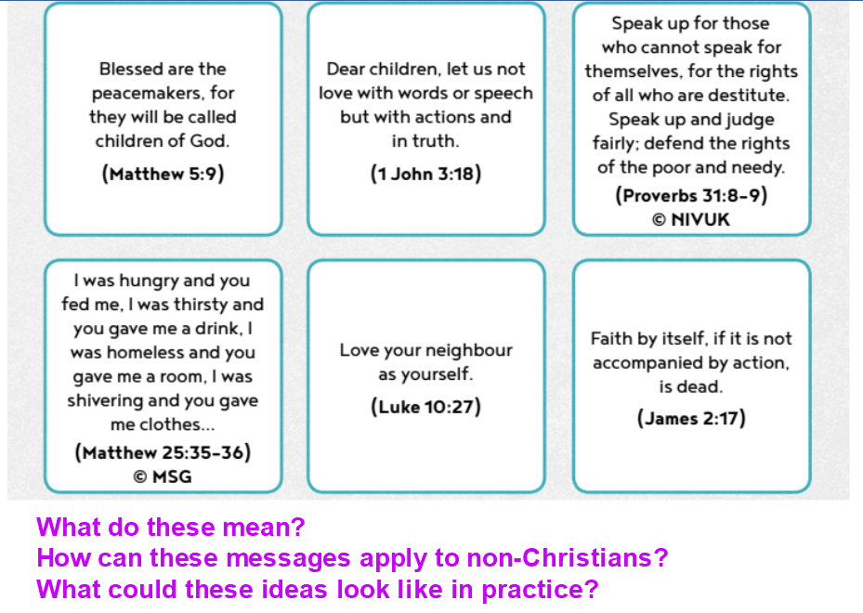

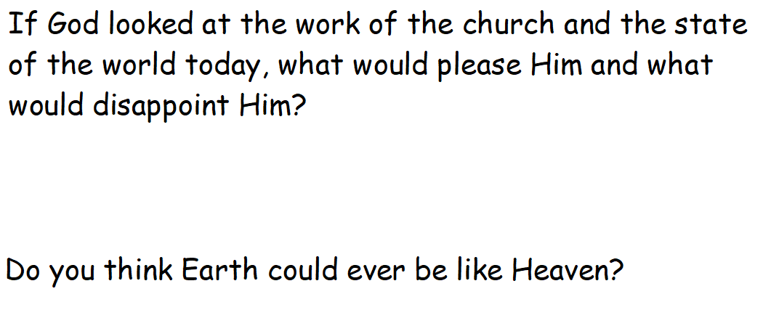

Think about the following questions. Try to answer them using your own thoughts, reflecting back on what we have learnt this half term.

- Do you think Heaven is the only place where God’s Kingdom could be 100% complete?
- In the ‘Kingdom of Forgiveness’, will some people be more likely to do bad things because they think they will not be punished?
- Heaven or justice? Does heaven matter more to Christians than justice here on Earth?
Should it?
- Did Jesus change the world? If so, how?
- What kind of ‘King’ was/is Jesus?
- Are there any lessons we could all learn from Christian ideas about God’s Kingdom of justice and love?

