To understand how belief in the resurrection is reflected in Christian worship.

Look at these pictures. What questions would you ask about them?
Can you say what is happening?
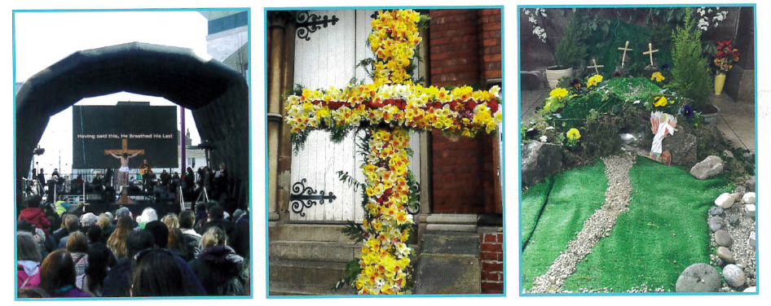

What is Good Friday about? What is Easter Sunday about?
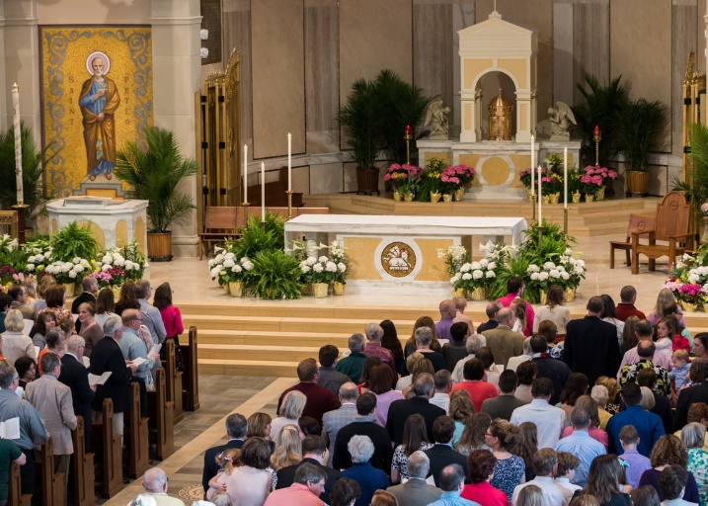
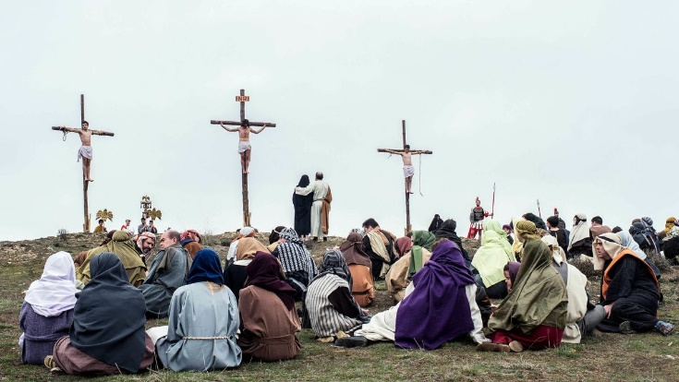
How does it make Christians feel?
How does it make Christians feel?

Write a paragraph to explain how the feelings of a Christian change from Good Friday to Easter Sunday.
See if you can explain reasons for why their feelings might change.
What is important about the belief in Resurrection to a Christian?

