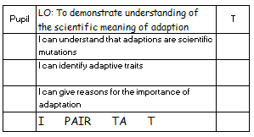
Match up the animal with the habitat it would naturally live in. Then match it to an explanation of how it has adapted.
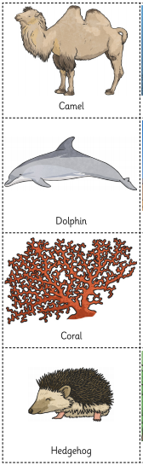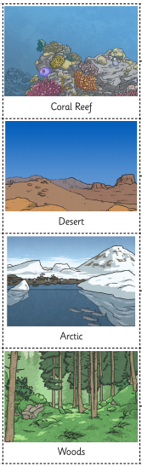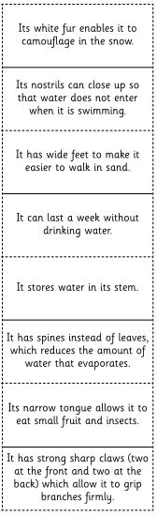
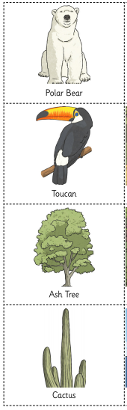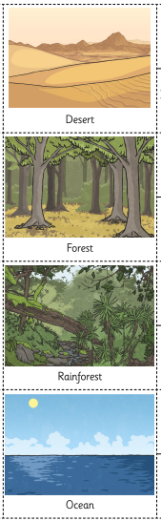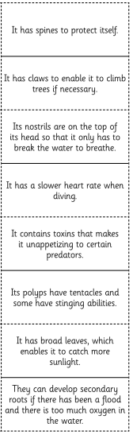

Activity 2
Think of an animal (preferably one that lives in the wild).

What is your animal? ___________________________________
What habitat does it live in? _________________________________________
What does the animal look like? Think about all parts of it: ears, eyes, nose, mouth, teeth, fur/skin, body shape, tail, claws/toes, legs, colour.
_____________________________________________________________________________________________
_____________________________________________________________________________________________
_____________________________________________________________________________________________
_____________________________________________________________________________________________
_____________________________________________________________________________________________

What does it eat? ______________________________________________________________________________
How does it catch its food? ______________________________________________________________________
_____________________________________________________________________________________________
How does it defend itself against predators? _________________________________________________________
_____________________________________________________________________________________________
What features do you think most help your chosen animal to survive in their habitat? Give reasons.
_____________________________________________________________________________________________
_____________________________________________________________________________________________
_____________________________________________________________________________________________
_____________________________________________________________________________________________
_____________________________________________________________________________________________
Think of your animal in a DIFFERENT habitat. Explain why it would probably not survive there.
_____________________________________________________________________________________________
_____________________________________________________________________________________________
_____________________________________________________________________________________________
_____________________________________________________________________________________________

