Section | Worked example | Features/Key questions
Diagram | 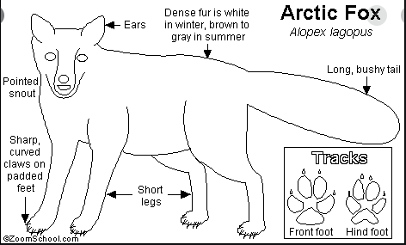 | Labels  Headings  Technical language
Introduction | The arctic fox, which is the smallest member of canine family, has 5 subspecies. Arctic foxes inhabit the tundra throughout the Arctic Circle. Arctic foxes can be found in Iceland, Greenland, Northern Europe, Russia, Canada and Alaska. | - To what family of animals does your creature belong?  - Where in the world can it be found?  - What is the collective noun for your animal?  Try to include a relative clause and technical language.

