Year 6 Homework - Set Thursday 7th September due Wednesday 13th September
Please remember to present your work neatly as you would in your class book.

- Practice your spellings.
- Complete the arithmetic questions below.
- Complete the retrieval activity
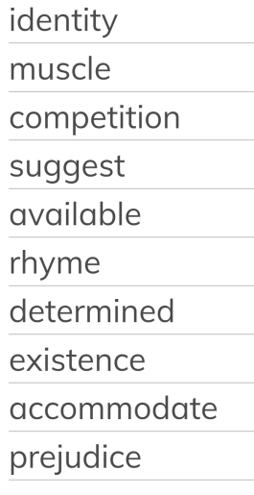

Arithmetic
1 8 7 0 6 2 5 6
What is the greatest 8 digit number you can make with these digits?
Write this number as words.
What is the smallest 7 digit number you can make (without zero at the beginning)?
What is the difference between these two numbers?
Can you show this on a bar model?

Maths Challenge
Science Retrieval

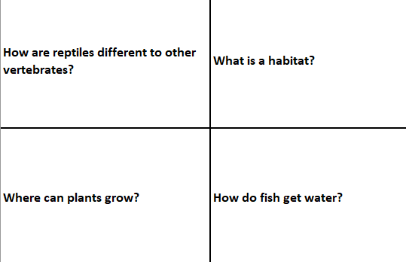

- If you would like to put yourself forward to become one of our School Ambassadors this year, write a speech explaining why.
The best speeches will be performed in assembly so the other year groups can see them and vote for their choices. You should think about:
- The skills needed to be an ambassador
- Your personality traits
- What makes you better qualified than others for this role
- What you will do to help the school
Please note: If you would prefer to be a House Captain, Eco Council Member or another role, adapt this task accordingly.

