Year 6 Homework - Set Thursday 28th September due Wednesday 4th October
Please remember to present your work neatly as you would in your class book.

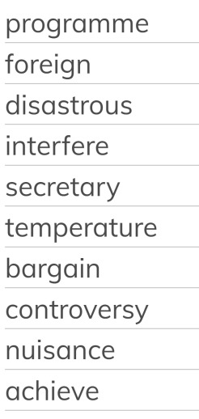
- Practice your spellings.
- Complete 6 arithmetic questions
- Complete the comprehension sheet attached
- Complete the retrieval activity
Arithmetic
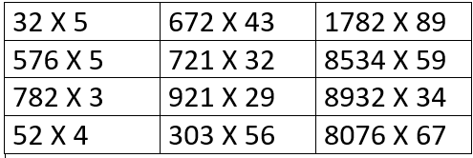

Retrieval
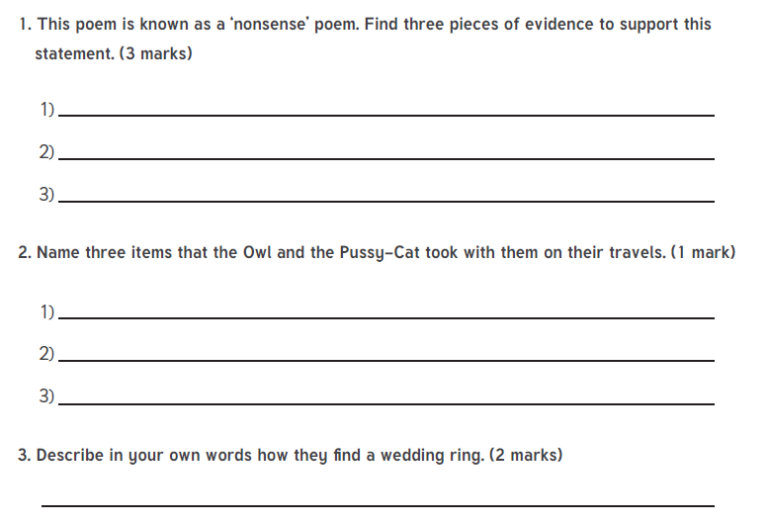
Can you match up these definitions from RE?

